Dear Keith,

Many thanks for your recent review of our paper “The AMPeror’s New Clothes: Performance in the Affect Misattribution Procedure is Mainly Driven by Awareness of Influence of the Primes” for JPSP. We were extremely grateful for your extensive, thoughtful, and comprehensive comments. We are currently busy designing one or more studies to address the concerns that you and the second reviewer highlighted.

To ensure that these new studies are of maximum utility, we would like to involve you in the design process and to include our correspondence in the preregisterations of any future studies. Our goal here is to only run those studies that directly speak to your questions. We would therefore appreciate your input on the logic of our arguments (*see below*), our characterisation of the existing literature, and how your concerns can be empirically addressed.

One of the main points in your review was that our various experiments (like most other published studies on this topic) failed to eliminate post-hoc confabulation as a potential explanation for AMP effects that are moderated by influence awareness. In other words, by asking participants about the influence of the prime on their target evaluations *immediately after* they had emitted those evaluations, any response to this question may still represent a post hoc confabulation on their part. You argued that, if so, then our results are consistent with the misattribution account; i.e., “participants can observe their own behavior and notice if they are responding in prime-consistent ways. If so, they can report afterward that they were influenced by the prime”.

We think a relatively simple modification to our existing paradigm would allow us to eliminate post-hoc confabulation as a potential explanation of our findings. Specifically, in our previous AMP experiments, participants were presented with a prime 🡪 blank screen 🡪 target 🡪 mask (which remained onscreen until an evaluative response was emitted). Only after emitting this evaluative response were they given the opportunity to emit an influence-awareness response (i.e., to indicate if the prime stimulus influenced their target evaluation). The aforementioned trial sequence can be altered in order to eliminate the possibility of post-hoc confabulation: the following trial sequence could be presented: prime 🡪 blank screen 🡪 target 🡪 mask and opportunity to emit an *influence-awareness* response 🡪 opportunity to emit target evaluation. That is, the order of presentation of the evaluative response and the influence-aware response are simply switched. In this way, one’s influence-awareness response cannot be confabulated with one’s target evaluation because the influence-awareness judgement is made before the evaluation itself is emitted.

If you agree with us then we propose to run an experiment that is very similar to Experiment 2 in our manuscript but uses an IA-AMP which is modified as outlined above (see Figure 1). As in Experiment 2, this would also examine whether the influence-awareness rate in the IA-AMP is *postdictive* of the absolute magnitude of the AMP effect on a previously completed standard AMP.

*Evaluative Response*

*Prime*

*Blank Screen*

*Target*

*Mask & Prime Influence Question*

***Unpleasant***

***Pleasant***

***Unpleasant***

***Pleasant***

***Pleasant***

***Unpleasant***

***Pleasant***

***Unpleasant***

***Unpleasant***

***Pleasant***

*Use E or I to evaluate the Chinese character*

***Press spacebar for influence***

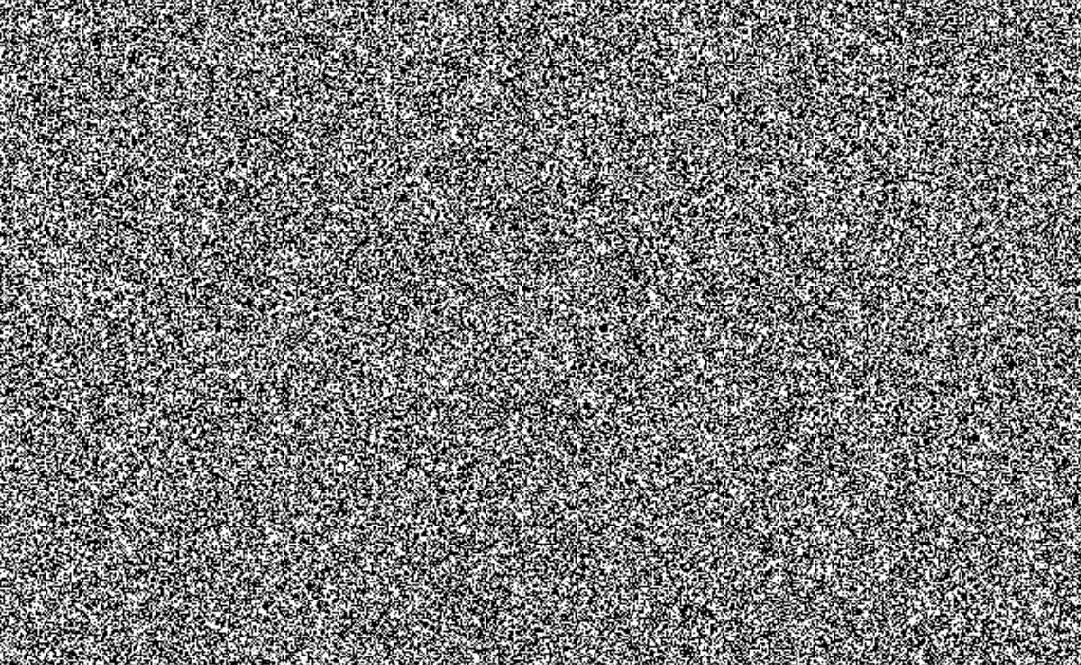

*Figure 1*. Trial sequence for a typical trial in the proposed study.

From our reading of Experiment 3 from Payne et al. (2013), this paradigm wholly aligns with the rationale which you used in the development of your ‘skip’ paradigm (i.e., participants reports of influence-awareness should be emitted before any evaluative response).

Would you agree with us that the aforementioned method effectively overcomes the issue of post-hoc confabulation? If not, could you tell us what, for you, is the feature that distinguishes between this proposed paradigm and that used in Experiment 3 of Payne et al. (2013), which you argued was effective in eliminating trials with prospective awareness?

We would appreciate your feedback on this revised version of our paradigm. If you disagree with our approach, we would also appreciate it if you could tell us the precise issues that you see with it. You can find the Inquisit script of the revised paradigm attached to this email. We also would like to thank you again for taking the time to review our manuscript and for providing critical and highly useful feedback.

Best regards

Jamie Cummins

Ian Hussey

Sean Hughes